Welcome to Course 2

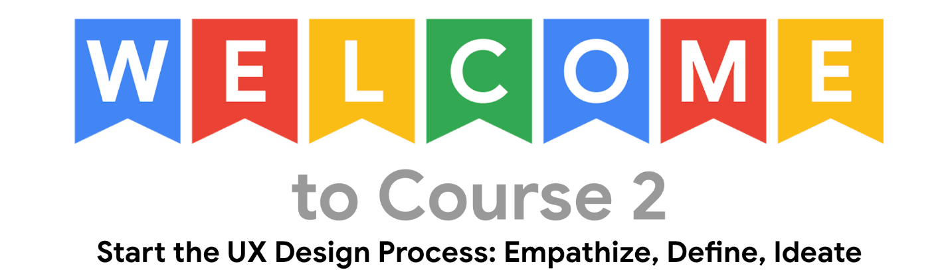

Welcome to Start the UX Design Process: Empathize, Define, Ideate, which is the second of seven courses in the Google UX Design Certificate. Your journey towards a career as a UX designer continues!

In this course, you will complete the first phases of the design process for a project that you’ll be able to include in your portfolio. You will learn how to empathize with users and understand their pain points, define user needs using problem statements, and come up with lots of ideas for solutions to those user problems. You will complete hands-on activities focused on designing a mobile app, which align with real tasks that UX designers complete on-the-job during these phases of the design process.

Content and projects in each course of this certificate program build on information practiced in earlier courses. To be successful in this course, you should complete the previous course of the certificate program, if you haven't already done so.

1. [Foundations of User Experience (UX) Design](https://www.coursera.org/learn/foundations-user-experience-design)
2. **Start the UX Design Process: Empathize, Define, Ideate -** *this course*
3. [Build Wireframes and Low-Fidelity Prototypes](https://www.coursera.org/learn/wireframes-low-fidelity-prototypes)
4. [Conduct UX Research and Test Early Concepts](https://www.coursera.org/learn/conduct-ux-research)
5. [Create High-Fidelity Designs and Prototypes in Figma](https://www.coursera.org/learn/high-fidelity-designs-prototype)
6. [Responsive Web Design in Adobe XD](https://www.coursera.org/learn/responsive-web-design-adobe-xd)
7. [Design a User Experience for Social Good & Prepare for Jobs](https://www.coursera.org/learn/ux-design-jobs)

Each course of the Google UX Design Certificate is broken into weeks. You can complete courses at your own pace, but the weekly breakdowns are designed to help you finish the program in about six months total.

So, what design skills can you expect to develop during this course? Here’s a preview of the hands-on activities you'll complete.

**Week 1: Empathizing with users and defining pain points.** Begin the design process for a mobile app! This part of the course will focus on understanding users, which is the first phase of the design process. You’ll empathize with fictional users to build empathy maps and create personas. These hands-on activities will help you understand user perspectives and pain points.

**Week 2: Creating user stories and user journey maps.** You'll continue to empathize with users of the mobile app you'll later design. You'll craft user stories and develop user journey maps. You’ll also learn about the importance of considering accessibility when empathizing with users.

**Week 3: Defining user problems.** All of your work to empathize with users will help you define the problem that users are facing. In this part of the course, you'll move from the empathize phase into the define phase of the design process. To define the problem your designs will solve, you’ll build a problem statement, a hypothesis statement, and a value proposition. In addition, you’ll explore how psychology and human factors influence design.

**Week 4: Ideating design solutions.** Move into the third phase of the design process: ideate. You'll consider everything you've learned about the users you're designing for and the problems they're facing in order to brainstorm ideas for design solutions. To help you come up with lots of ideas for design solutions, you’ll conduct a competitive audit and complete design activities, like How Might We and Crazy Eights.

Keep in mind that if you want to obtain the Google UX Design Certificate, you must complete all graded materials in all courses of the certificate program and earn a score of 80% or higher. Graded materials are located at the end of each week and are indicated with the name "weekly challenge."

Good luck beginning the design process for your first portfolio project: designing a mobile app!